 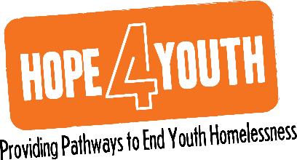

**HOPE4YouthMN.org**

**763.323.2066**

2665 4th Avenue North I Suite 40

Anoka, Minnesota 55303

**February 2022 Finance Committee Meeting**

**February 10, 2022**

**Agenda**

1. Review of January Financials
   1. Committee likes the new layout and detail
   2. It will be helpful when monthly spread is complete – due by February financials
   3. Look into H4Y’s current written *Investment Plan*
      1. If one does not exist work to create one
         1. Bringing to Executive Committee to discuss broad knowledge of plan, timing and priority of creation if needed
   4. Review and socialize cash reserves policy for H4Y
   5. Prepare and socialize monthly cash flow update with PY comparison
      1. Include number of months of cash on hand
2. Review and discussion regarding new structure and recommendations
   1. It is strongly recommended that we create a simplified version of the monthly financials for the general board.
   2. Staff will post detailed version in the Board Portal but will share roll-up for general board review.
   3. Always provide general board with 3-4 points of deeper understanding than what the numbers visually reveal. Focus on anything $10K over or under - i.e. PPP revenue shift, program expense reduction in Jan due to high volume of donations in Dec, etc…
3. Financial Controller Level Support to H4Y
   1. H4Y plans to end the relationship with MMC by the end of February 2022.
   2. Tanya Bacigalupo is planned to begin oversight as a Controller Level contractor on or near March 2, 2022.
   3. Tanya will reach out to Don and Sarah in the coming days/weeks
4. General discussion
   1. Committee encourages H4Y to further socialize “what success looks like” – point to our outcomes
   2. Education of Board Portal requested – in the plan
   3. Focused fund raising plans spread throughout the year
      1. Discussed needed balance for operations needs to keep the doors opened and the energy behind specific asks such as a Scholarship Fund.