Pat Chen
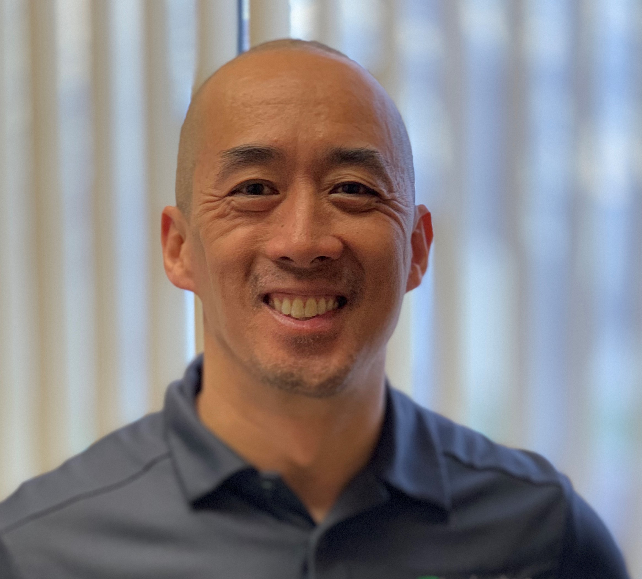

Pat Chen is the Human Resources Director at Lexington Manufacturing, a supplier and contract manufacturer of components for windows, doors and other building-related millwork. Lexington is dedicated to providing their customers with innovative, market-leading products that are delivered with integrity and value. Lexington has 300 employees in their Coon Rapids and Brainerd plants and has continued to grow and succeed through their commitment to service and quality - by providing innovative solutions, quality products and short lead times since they were founded in 1981.. Lexington’s mission is “Building Relationships, Creating Solutions, Delivering Value”, and their five core values are Team, Our Word, Can Do, Growth and People.

Pat was hired in 2018 as the first HR executive leader in the company’s history and has built a highly engaged and cohesive team responsible for all people-focused areas of the company including talent acquisition, employee experience and engagement, total rewards, employee development and training, and pandemic response.

Prior to joining Lexington, Pat worked as an HR leader in a variety of industries including service, higher education, retail and utilities. Pat has been a long-time board member and supporter of Brooklyn Park Athletic Association which provides sports programs and activities for boys and girls in Brooklyn Park where Pat and his family reside.

Pat received a BA in Psychology from St. Olaf College, and a MA in Industrial Relations from the University of Minnesota Carlson School of Management.

