 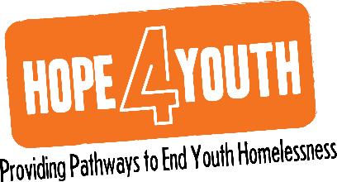

**HOPE4YouthMN.org**

**763.323.2066**

2665 4th Avenue North I Suite 40

Anoka, Minnesota 55303

**Executive Committee Meeting**

**June 13th, 2022**

**Agenda**

1. **Financials Review**
   * 1. Review of updated Audit and 990
     2. Review of Highlight points of May financials:
2. **Operational Update**
   * 1. Board meeting structure – recommend Consent Agenda
3. **March Board Meeting**
   1. Agenda for June 20th Retreat
4. **Other Business**