 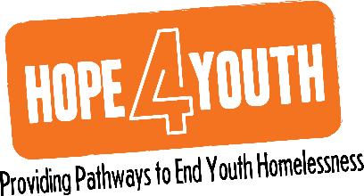

**HOPE4YouthMN.org**

**763.323.2066**

2665 4th Avenue North I Suite 40

Anoka, Minnesota 55303

**July 2022 Finance Committee Meeting**

**August 11, 2022**

**4:00pm- 5:00pm**

**Agenda**

1. Review of July Financials

Highlight points:

* Cash and reserves on hand – 8.3 months
* Balance sheet comparison to 2021 – includes previously discussed changes
* We are trending slightly ahead in revenue this month but are behind YTD due to Individuals and Civic|Faith organizations being down.  We will drop a Summer Appeal soon hoping to raise the necessary funds to close this gap.
* Expenses are down in July and YTD due to management of expenses, Pohlad plans, and timing of expenditures.
* The use of reserves will not impact our monthly financials; however, I will reference this at each of our monthly reviews.
* We are working with ABDO Solutions to complete the application for the Employee Tax Credit program.  We learned the funding from the IRS is slow and could take between six-ten months. We confirmed we will be able to book the funds in 2022 once the application is filed.

1. Update banking recommendation progress
   1. HOPE Place Mortgage – August 24th payoff plan
   2. 21st Century Line of Credit – we will move forward after we receive the Satisfaction of Mortgage (timing pending in September)
   3. Exploration of sale of AO – we have an interested buyer. Committee asks that we negotiate staying in the building for as long as possible. We will engage Steve Nash for a legal review of the pending Purchase Agreement.
2. 21st Century IntraFi Network Deposit program – this is a free program allowing us to be protected beyond the $250,000 insurability levels in place with our banking partners. We will be moving forward to transfer our Board Reserves to this deposit program in September.
3. Open Discussion
   1. Robust discussion on next steps to leverage cash reserves. Don asked that we move forward with the purchase of Treasury Bills. LaChelle to take recommendation to the Executive Committee for approval.
   2. LaChelle will need to determine timing and cash flow options. She will bring to August ECM.
   3. LaChelle will work with Tanya to revise Banking Roadmap.
4. Adjourn 5:00pm